
AMERICAN INTERNATIONAL UNIVERSITY BANGLADESH

Faculty of Engineering
Laboratory Report Cover Sheet

Students must complete all details except the faculty use part.
Laboratory Title: Experiment Number: Due Date: Semester: Subject Code: EEE Subject Name: Section: Course Instructor: Degree Program:
Please submit all reports to your subject supervisor or the office of the concerned faculty.

Declaration and Statement of Authorship:
- I/we hold a copy of this report, which can be produced if the original is lost/ damaged.
- This report is my/our original work and no part of it has been copied from any other student’s work or from any other source except where due acknowledgement is made.
- No part of this report has been written for me/us by any other person except where such collaboration has been authorized by the lecturer/teacher concerned and is clearly acknowledged in the report.
- I/we have not previously submitted or currently submitting this work for any other course/unit.
- This work may be reproduced, communicated, compared and archived for the purpose of detecting plagiarism.
- I/we give permission for a copy of my/our marked work to be retained by the School for review and comparison, including review by external examiners.

I/we understand that
- Plagiarism is the presentation of the work, idea or creation of another person as though it is your own. It is a form of cheating and is a very serious academic offence that may lead to expulsion from the University. Plagiarized material can be drawn from, and presented in, written, graphic and visual form, including electronic data, and oral presentations. Plagiarism occurs when the origin of the material used is not appropriately cited.
- Enabling plagiarism is the act of assisting or allowing another person to plagiarize or to copy your work
Group Number (if applicable): Individual Submission Group Submission

 | No. | Student Name | Student Number |  | Student Signature | Date
 | Submitted by:
 | 1
 | Group Members:
 | 2
 | 3
 | 4
 | 5
For faculty use only: |  |  |  | Total Marks: Marks Obtained:
Faculty comments
Abstract:
This experiment was conducted to study the characteristics of different digital logic gates and to understand the implementation of basic logic gates using universal gates. The operations of AND, OR, NOT, NAND, NOR, XOR, and XNOR gates were investigated using digital integrated circuits and a digital trainer board. The truth tables of the logic gates were verified by observing their output states for different input combinations. Furthermore, NAND and NOR gates were used to implement basic logic functions and construct other logic gates. The experimental results were compared with the expected truth tables to verify the correct operation of the circuits. The experiment successfully demonstrated the working principles of digital logic gates and the use of universal gates in designing digital circuits.
Objective:
To study different digital logic gates and design basic logic gates using universal gates.
Introduction:
Digital logic gates are the basic building blocks of digital electronic circuits. They perform logical operations on binary inputs, which are represented by 0 and 1, to produce a specific output. The basic logic gates include AND, OR, NOT, NAND, NOR, XOR, and XNOR. Each gate performs a different logical operation according to its truth table.
Among these gates, NAND and NOR are known as universal gates because they can be used to construct all other basic logic gates. In this experiment, different logic gates are studied using integrated circuits (ICs) and a digital trainer board. Basic logic gates are also designed using NAND and NOR gates, and their outputs are verified by comparing the experimental results with the corresponding truth tables.
Theory:

Part I (Basic Logic IC’s):
An integrated circuit (also referred to as an IC, a chip, or a microchip) is a set of electronic circuits on one small plate ("chip") of semiconductor material, normally silicon. This can be made much smaller than a discrete circuit made from independent components. Different integrated circuits are used to implement different logical operations in the trainer board which will be introduced in this experiment.
In analog signals, information is translated into electric pulses of varying amplitude but in case of digital, translation of information is in binary format (zero or one) where each bit is representative of two distinct amplitudes
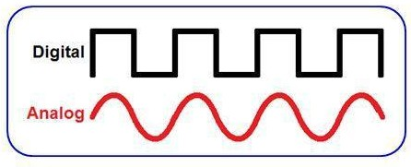
Figure 1: Digital, Analog Amplitudes
The main advantage of digital signals over analog signals is that the precise signal level of the digital signal is not vital. This means that digital signals are fairly immune to the imperfections of real electronic systems which tend to spoil analog signals. Codes are often used in the transmission of information. These codes can be used either as a means of keeping the information secret or as a means of breaking the information into pieces that are manageable by the technology used to transmit the code. It can convey information with greater noise immunity, because each information component (byte etc) is determined by the presence or absence of a data bit (0 or one). Analog signals vary continuously and their value is affected by all levels of noise. Digital signals can be processed by digital circuit components, which are cheap and easily produced in many components on a single chip. It uses typically less bandwidth with less electromagnetic interference. Moreover, Information storage can be easier in digital systems than in analog ones. The noise-immunity of digital systems permits data to be stored and retrieved without degradation.

There are two sorts of circuits which are known as integrated circuit and discrete circuit. The two main advantages of ICs over discrete circuits are cost and performance. Cost is low because the chips, with all their components, are printed as a unit by photolithography rather than being constructed one transistor at a time. Furthermore, much less material is used to construct a packaged IC die than to construct a discrete circuit. Performance is high because the components switch quickly and consume little power (compared to their discrete counterparts) as a result of the small size and close proximity of the components.

A logic gate is an elementary building block of a digital circuit. Most logic gates have two inputs and one output. At any given moment, every terminal is in one of the two binary conditions low (0V) and high (5V), represented by different voltage levels. The logic state of a terminal can, and generally does, change often, as the circuit processes data. In most logic gates, the low state is approximately zero volts (0 V), while the high state is approximately five volts positive (+5 V).

There are seven basic logic gates: AND, OR, NOT, NOR, NAND,XOR and XNOR. Different logic operations of different IC’s will be introduced which perform the following characteristics:

Operation | Expression
AND | Y=AB
OR | Y=A+B
NOT | 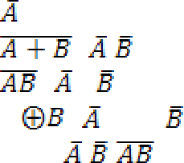  Y=
NOR | Y= | =
NAND | Y= = | +
XOR | Y=
XNOR | Y=

AND operation:
The AND operation produces a high if and only if all the inputs are high. An AND gate can have two or more inputs and performs AND operation or logical multiplication.

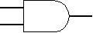
Fig1.1: Symbol of AND gate

Truth Table:

Input, A | Input, B | Output, F
0 | 0 | 0
0 | 1 | 0
1 | 0 | 0
1 | 1 | 1

Pin configuration for IC-74HC08N :
For a quadrature 2input AND gate HC08 davice code is used. 74HC series devices are designed to work with a 5 V power supply, voltages from 2 V to 5 V are allowed and most circuits work well using 5 V.

OR operation:
The OR operation produces a high output when any of the inputs are high. It has two or more inputs and one output which performs OR operation or logical addition.

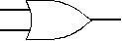
Fig 1.2: Symbol of OR gate
Truth Table:
Input, A | Input, B | Output, F
0 | 0 | 0
0 | 1 | 1
1 | 0 | 1
1 | 1 | 1

Pin configuration for IC-74HC32N:

HC32 is the device code. 74HC32 is a Quad 2-input OR gate (High Speed CMOS version) which has lower current consumption/wider Voltage range from 2 to 5V. It requires low input current of 1μA with high noise immunity characteristics of CMOS devices.

NOT operation:
The NOT operation changes one logic level to the opposite logic level. It is implemented by a logic circuit known as an inverter.

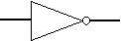
Fig1.3: Symbol of NOT gate

Truth Table:

Input, A | Output, F
0 | 1
1 | 0

Pin configuration for IC-74HC04N :

The 74HC04 is a hex inverter which consists of six inverters which perform logical invert action. The inputs include clamp diodes that enable the use of current limiting resistors to interface inputs to voltages in excess of VCC. The Input level for 74HC04 is CMOS level .

NAND operation:

The NAND gate operates as an AND gate followed by a NOT gate. It acts in the manner of the logical operation "AND" followed by negation. The output will be low if both inputs are high. Otherwise, the output is high.

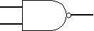

Fig 1.4: Symbol of NAND gate
Truth Table:
Input, A | Input, B | Output, F
0 | 0 | 1
0 | 1 | 1
1 | 0 | 1
1 | 1 | 0

Pin configuration for IC-74HC00N :
HC00 is the device code. The device inputs are compatible with Standard CMOS outputs; with pullup resistors. The operating voltage range is 2.0 to 5.0 V and low input current is 1.0 µA.

NOR operation:
The NOR gate is a combination OR gate followed by an inverter. Its output is high if both inputs are low. Otherwise, the output is low.

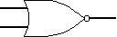

Fig 1.5: Symbol of NOR gate

Truth Table:
Input, A | Input, B | Output, F
0 | 0 | 1
0 | 1 | 1
1 | 0 | 1
1 | 1 | 0

Pin configuration for IC-74HC00N :

HC00 is the device code. The device inputs are compatible with Standard CMOS outputs; with pullup resistors. The operating voltage range is 2.0 to 5.0 V and low input current is 1.0 µA.

XOR operation:
The XOR (exclusive OR) gate acts in the same way as the logical "either/or" .The output is high if either, but not both, of the inputs are high. The output is low if both inputs are low or if both inputs are high. Another way of looking at this circuit is to observe that the output is 1 if the inputs are different, but 0 if the inputs are the same.

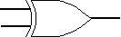

Fig 1.6: Symbol of XOR gate
Truth Table:
Input, A | Input, B | Output, F
0 | 0 | 0
0 | 1 | 1
1 | 0 | 1
1 | 1 | 0

Pin configuration for IC-74HC86N :
HC86 is the device code for a quad 2-input xor gate which utilizes advanced silicon gate CMOS technology . It maintains low power consumption and high noise immunity characteristic of standard CMOS integrated circuits. The 74HC logic family has a voltage
range of 2V to 5V and the operating temperature is -40°C to 125°C with input current of 1µA.

XNOR operation:
The XNOR (exclusive-NOR) gate is a combination XOR gate followed by an inverter. Its output is high if the inputs are the same, and low if the inputs are different.

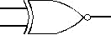

Fig 1.7: Symbol of XNOR gate
Truth Table:
Input, A | Input, B | Output, F
0 | 0 | 1
0 | 1 | 0
1 | 0 | 0
1 | 1 | 1

Using combinations of logic gates, complex operations can be performed. Arrays of logic gates
are found in digital integrated circuits (ICs). As IC technology advances, the required physical volume for each individual logic gate decreases and digital devices of the same or smaller size become capable of performing ever more complicated operations at ever- increasing speeds.

Apparatus:
- Digital trainer board.
- Integrated Circuits (ICs).
- Power supply.
- Connecting wires.
- Integrated Circuits (ICs):
7400 : 1 pcs
7402 : 1 pcs
7404 : 1 pcs
7408: 1 pcs
7432 : 1 pcs
7486 : 1 pcs

Precautions:

Integrated circuits (ICs) have built-in protection circuits that help prevent damage caused by high static voltages and electric fields. However, the applied voltage must remain within the maximum rated limits of the IC. For proper operation, both the input voltage (Vin) and the output voltage (Vout) should be maintained between ground (GND) and the supply voltage (VCC).

IC configurations:

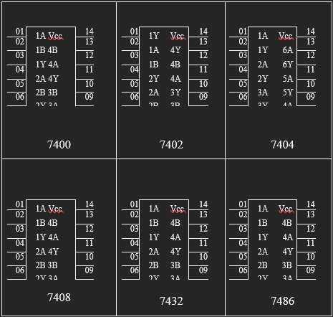
Theory:
Part II: Study of Universal Gates
A Logic Gate which can infer any of the gate among Logic Gates or a gate which can be used to create any Logic gate is called Universal Gate. NAND and NOR Gates are called Universal Gates because all the other gates such as NOT, AND, OR, XOR, XNOR etc can be created by using these gates.

The Objective of this lab is to implement different logic functions using universal gates.

NAND gate:
The graphic symbol for the NAND gate consists of an AND symbol with a bubble on the output, denoting that a complement operation is performed on the output of the AND gate.

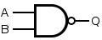

Fig 2.1: Symbol of NAND gate
Truth Table

Input A | Input B | Output Q
0 | 0 | 1
0 | 1 | 1
1 | 0 | 1
1 | 1 | 0

It is possible to construct other gates using NAND gates which are shown in Experimental procedure part.
Implementing various logic functions using NAND Gates:

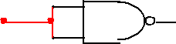
- Implementing NOT gate using NAND gate:

A | Y
NOT gate using NAND gate

- Implementing AND gate using NAND gate:

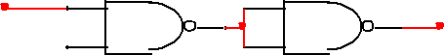
A Y
B
AND gate using NAND gates

- Implementing OR gate using NAND gate:
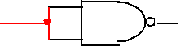
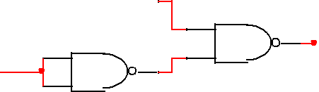
A
Y
B

OR gate using NAND gates

NOR gate:
The NOR gate represents the complement of the OR operation. It’s name is an abbreviation of NOT OR. The graphic symbol for the NOR gate consists of an OR symbol with a bubble on the output, denoting that a complement operation is performed on the output of the OR gate. The truth table and the graphic symbol of NOR gate is shown in the figure.

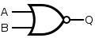
Fig 2.2: Symbol of NOR gate

Truth Table
Input A | Input B | Output Q
0 | 0 | 1
0 | 1 | 0
1 | 0 | 0
1 | 1 | 0

Implementing various logic functions using NOR Gates:

- Implementing NOT gate using NOR gate:

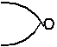

A Y
NOT gate using NOR gate

- Implementing AND gate using NOR gate:

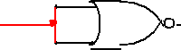
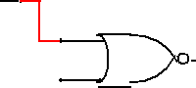
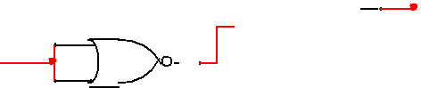
A

Y
B

AND gate using NOR gates
- Implementing OR gate using NOR gate:

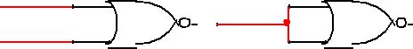
A
Y
B
OR gate using NOR gates

Apparatus:
  - Digital trainer board.
  - Integrated Circuits (ICs).
  - Power supply.
  - Connecting wires.

Precautions:

All circuit connections should be checked by the instructor after the setup is completed. The IC should be supplied with the appropriate voltage to ensure proper operation and prevent possible damage.

Experimental Procedure:
1. An XOR gate and an XNOR gate are constructed on the digital trainer board using only NAND gates and the required ICs.
2. Equivalent NOT, OR, and AND gates are implemented using only NOR gates. Then, XOR and XNOR gates are constructed on the digital trainer board using only NOR gates and the required ICs.
3. The following Boolean expressions are implemented using universal gates on the digital trainer board. The obtained outputs are compared with the corresponding truth tables to verify the results.
i) A(+)B
ii) ((A (+)B)+C
iii) (AB+CD)
Data Table:
OR
AND
Input A | Input B | Output F
0 | 0 | 0
0 | 1 | 0
1 | 0 | 0
1 | 1 | 1
Input A | Input B | Output F
0 | 0 | 0
0 | 1 | 1
1 | 0 | 1
1 | 1 | 1

(AB + CD)
XOR

Input A | Input B | Output F
0 | 0 | 0
0 | 1 | 1
1 | 0 | 1
1 | 1 | 0
Input A | Input B | Input C | Input D | Output F
0 | 0 | 0 | 0 | 1
0 | 0 | 0 | 1 | 1
0 | 0 | 1 | 0 | 1
0 | 0 | 1 | 1 | 1
0 | 1 | 0 | 0 | 1
0 | 1 | 0 | 1 | 1
0 | 1 | 1 | 0 | 1
0 | 1 | 1 | 1 | 0
1 | 0 | 0 | 0 | 1
1 | 0 | 0 | 1 | 1
1 | 0 | 1 | 0 | 1
1 | 0 | 1 | 1 | 1
1 | 1 | 0 | 0 | 0
1 | 1 | 0 | 1 | 0
1 | 1 | 1 | 0 | 0
1 | 1 | 1 | 1 | 0
Input A | Input B | Input C | Output F
0 | 0 | 0 | 1
0 | 0 | 1 | 1
0 | 1 | 0 | 0
0 | 1 | 1 | 0
1 | 0 | 0 | 0
1 | 0 | 1 | 0
1 | 1 | 0 | 1
1 | 1 | 1 | 1

(A(+)B)+C

Simulations
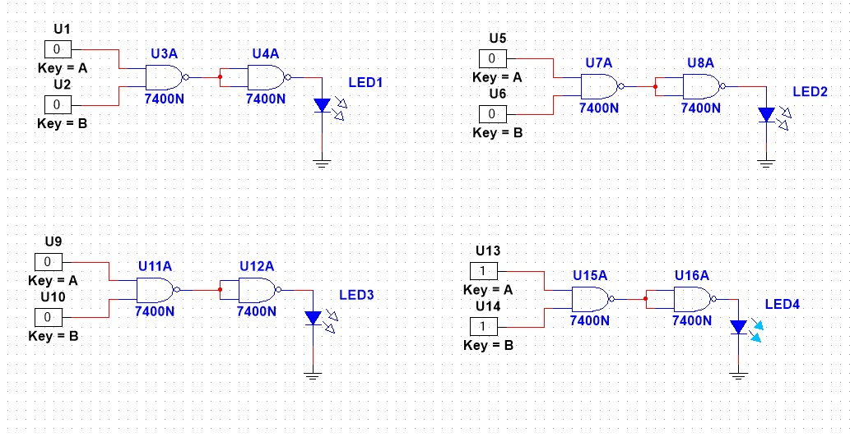

AND gate using NAND

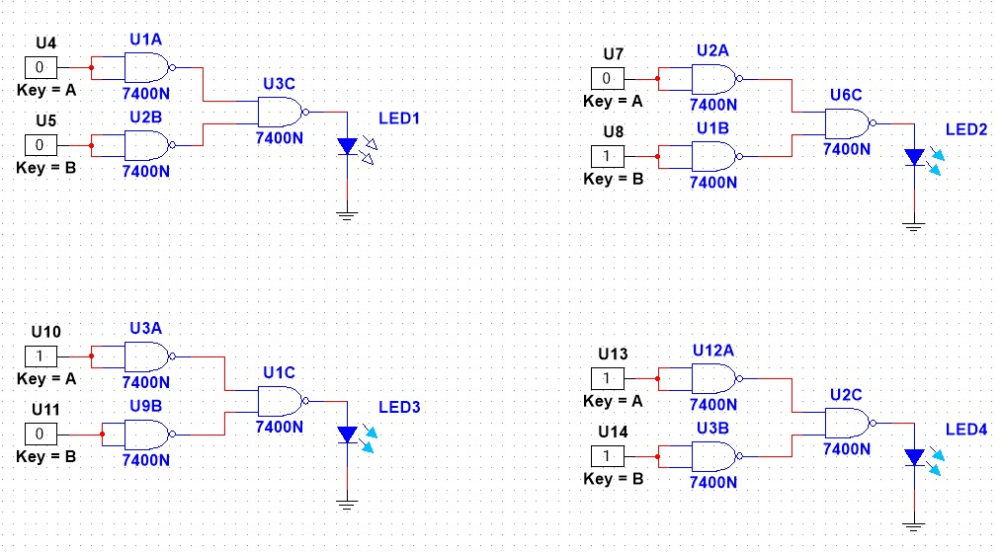
OR gate using NAND
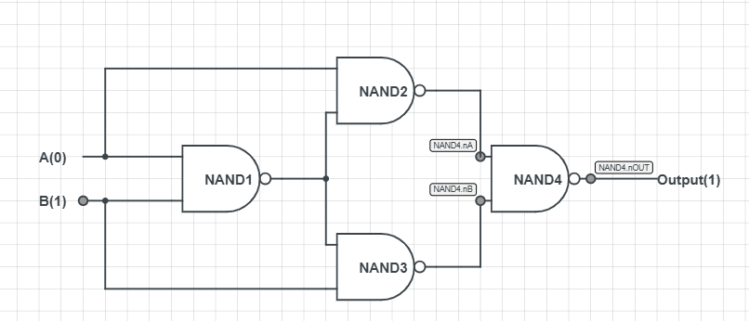
XOR gate using NAND (For 01)
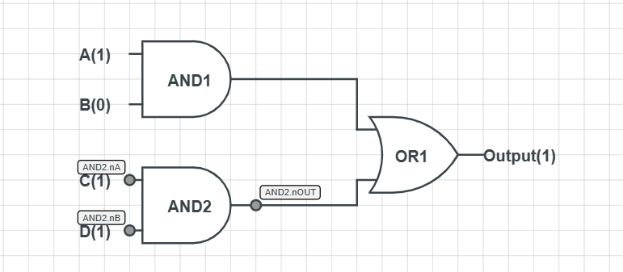
(AB+CD) (For 1011)

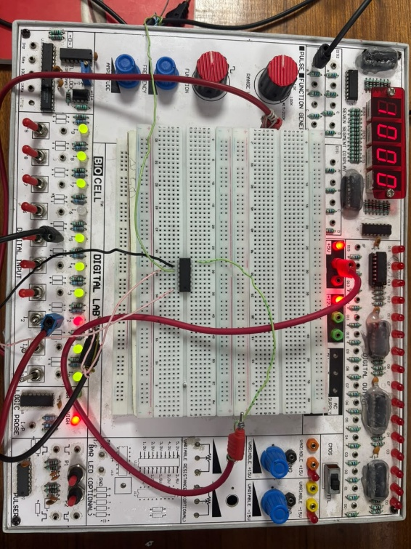
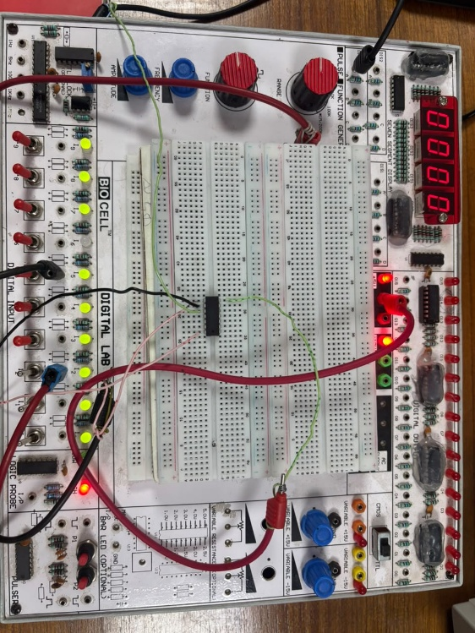
Hardware Setup :
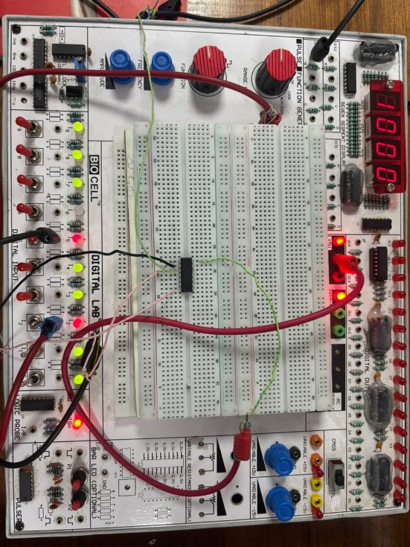
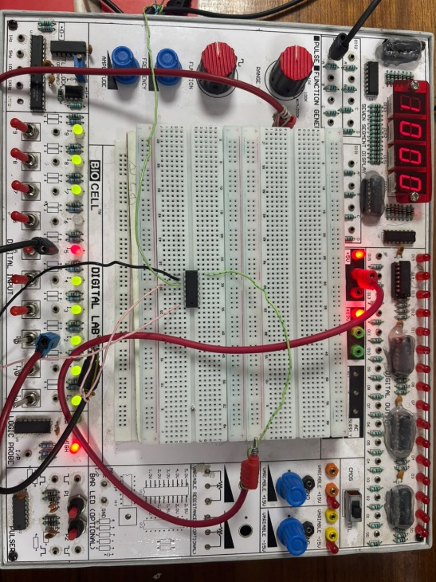

Or Gate

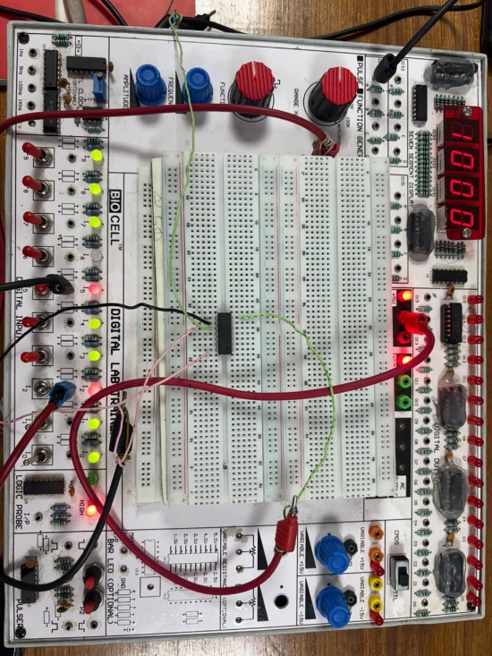
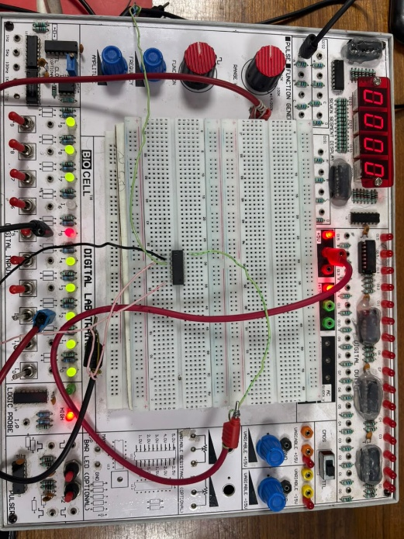
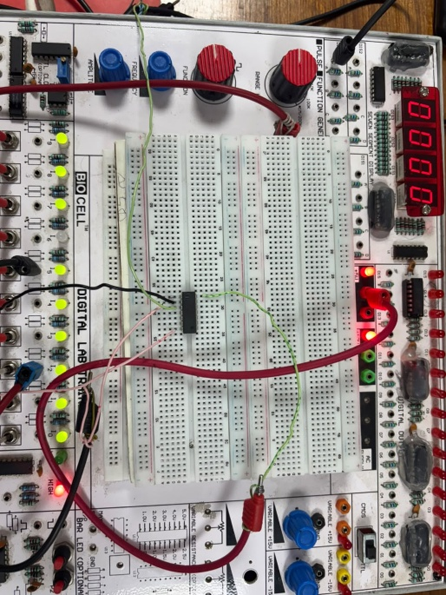
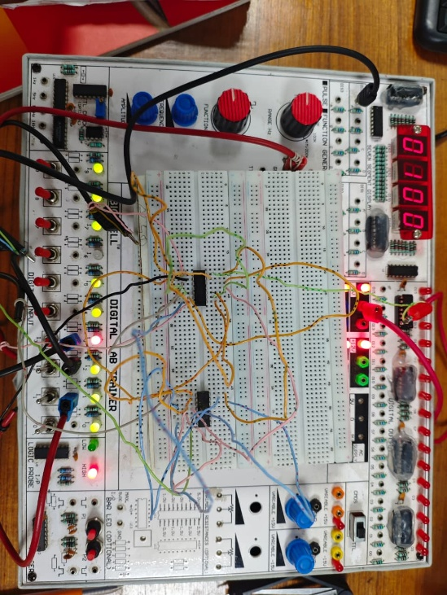
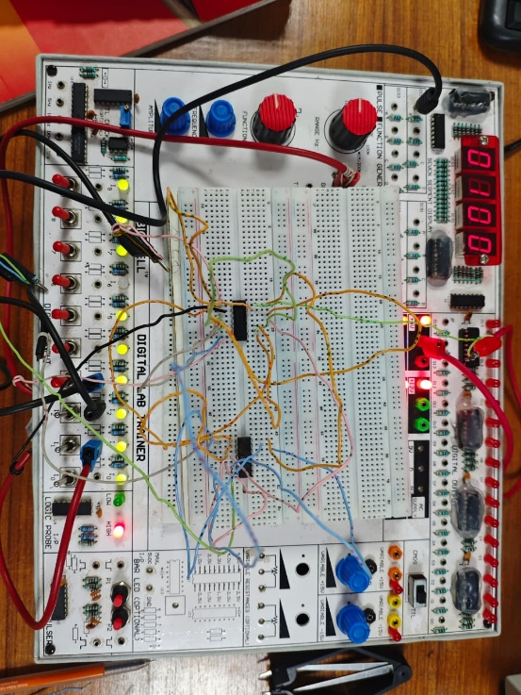
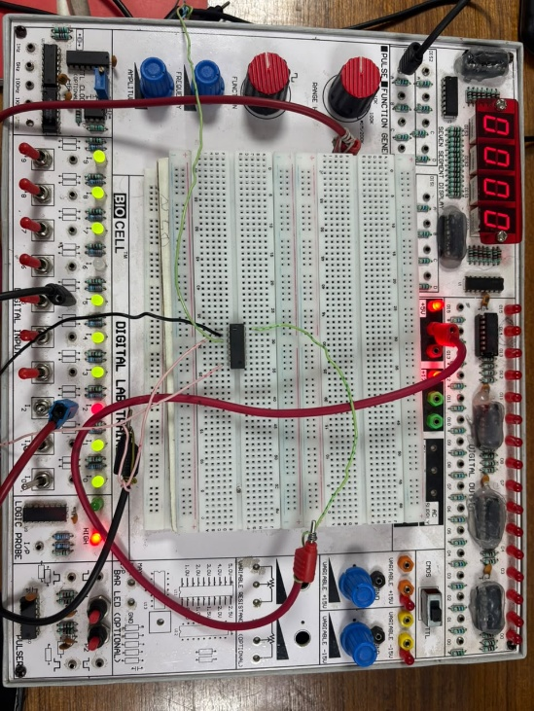
And Gate

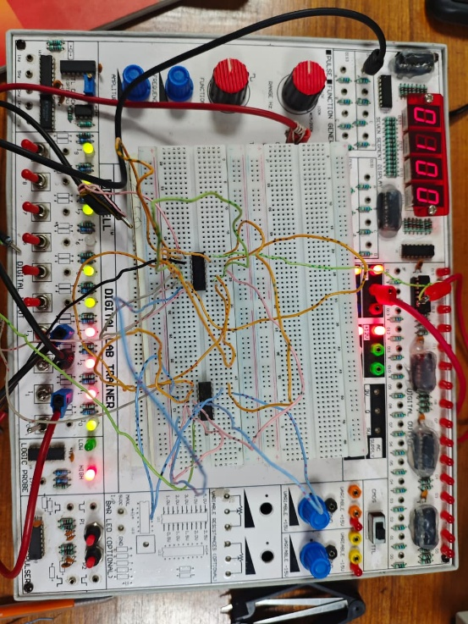
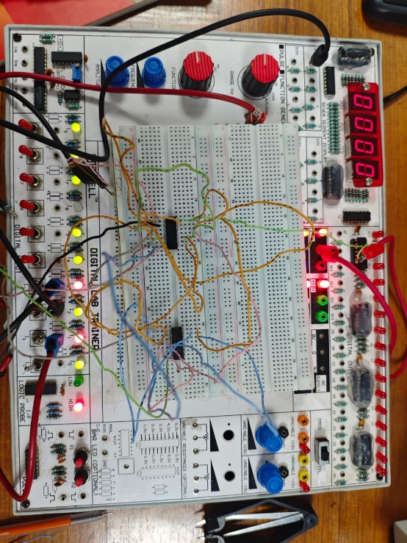
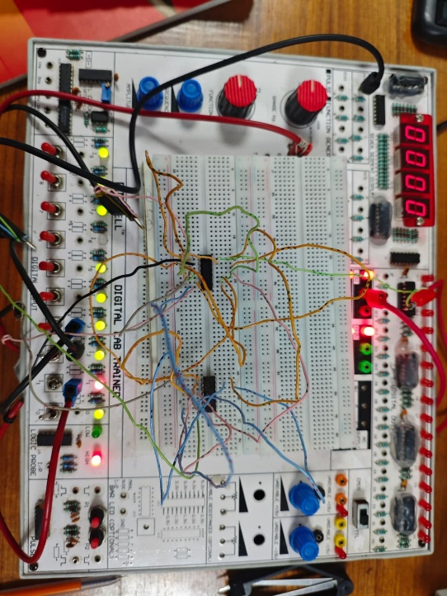
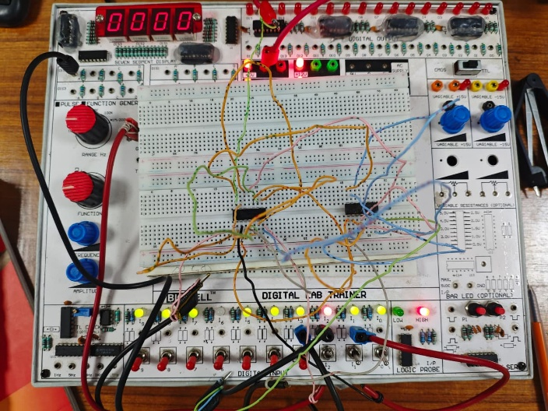
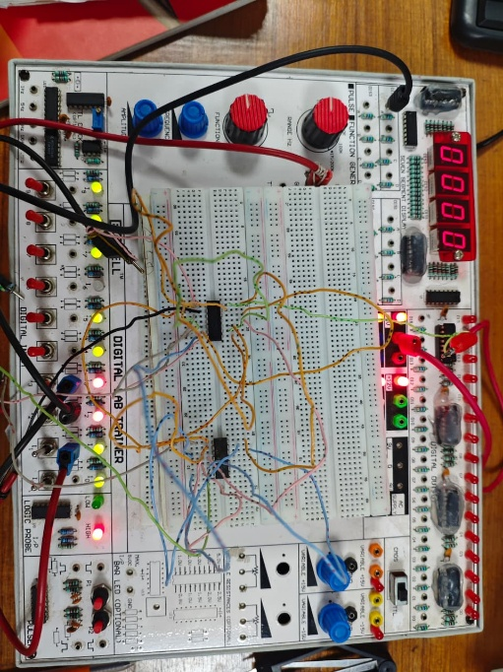

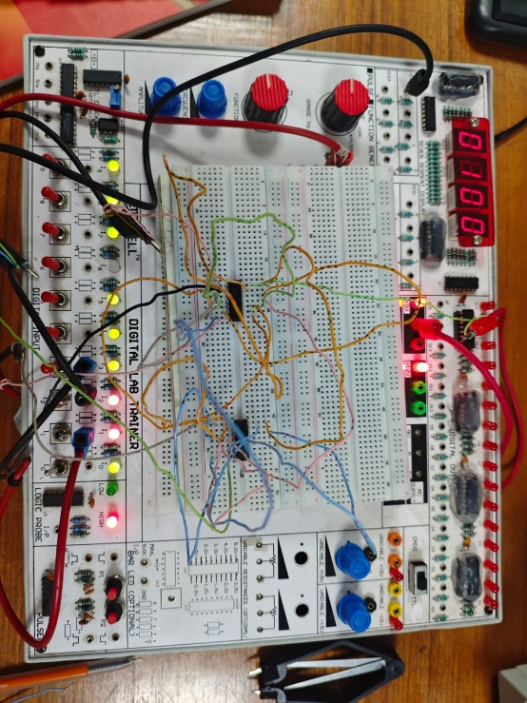
(A(+)B)+C

Q/A Part:
- What do you mean by universal gate?
Ans: A universal gate is a logic gate that can be used to construct all other basic logic gates. NAND and NOR gates are known as universal gates because NOT, AND, OR, XOR, and XNOR gates can be implemented using them.

- What are the ICs required in this experiment?
Ans: The ICs required for this experiment are:
- IC 7400 – NAND gate
- IC 7402 – NOR gate
- IC 7404 – NOT gate
- IC 7408 – AND gate
- IC 7432 – OR gate
- IC 7486 – XOR gate

Discussion:
The experimental results show that the output states of the logic gates followed the expected truth tables. The basic logic gates, including NOT, AND, and OR, were successfully implemented using universal NAND and NOR gates. The XOR and XNOR gates were also constructed using NAND and NOR gates only.
The experimental results followed the expected logical behavior. Small differences in the observed outputs, if any, could occur due to incorrect connections, loose wires, or improper input voltage levels.
The experiment demonstrated that NAND and NOR gates can be used to implement different Boolean functions without requiring separate ICs for every logic gate. Overall, the experiment successfully verified the operation of digital logic gates and demonstrated the importance of universal gates in digital circuit design.
Conclusion:
The experiment successfully achieved its goal of studying different logic gates and implementing basic gates using universal gates. The outputs matched the expected truth tables. Minor errors could occur due to loose connections or incorrect input voltages. In the future, universal gates can be used to design more complex digital circuits.

